**Practical – 2**

**Question – 1**

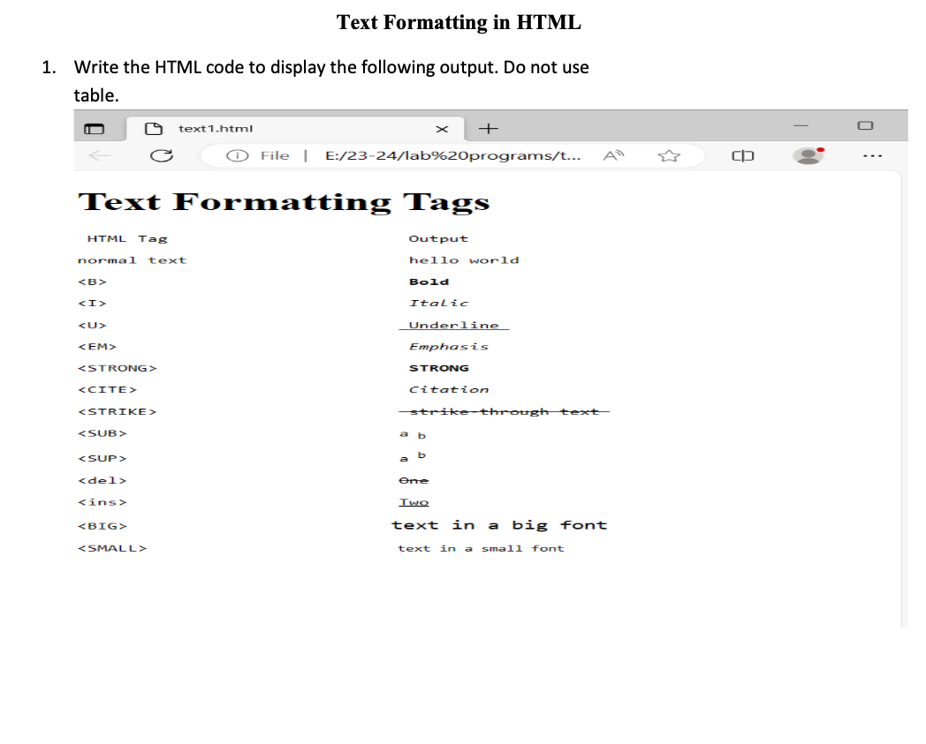

**HTML Code**

<!-- Html Text Formating -->

<!DOCTYPE html>

<html lang="en">

<head>

<meta charset="UTF-8">

<meta name="viewport" content="width=device-width, initial-scale=1.0">

<title>Formatting Tags</title>

</head>

<body>

<h1>Text Formating Tags</h1>

<pre>

Html Tag Output

normal text hello world

<code>&lt;B&gt;</code> <b>Bold</b>

<code>&lt;I&gt;</code> <i>Italics</i>

<code>&lt;U&gt;</code> <u>Underline</u>

<code>&lt;EM&gt;</code> <em>Emphasis</em>

<code>&lt;Strong&gt;</code> <stong>Strong</strong>

<code>&lt;Cite&gt;</code> <cite>Citation</cite>

<code>&lt;Strike&gt;</code> <strike>Strike Through Text</strike>

<code>&lt;Sub&gt;</code> a<sub>b</sub>

<code>&lt;Sup&gt;</code> a<sup>b</sup>

<code>&lt;del&gt;</code> <del>One</del>

<code>&lt;ins&gt;</code> <ins>Two</ins>

<code>&lt;Big&gt;</code> <big>Big</big>

<code>&lt;Small&gt;</code> <small>Small</smail>

</pre>

</body>

</html>

**Output**

